Genre-based Approach to Enhancing Secondary Students' English Writing Ability in Science Subjects

City University of Hong Kong, Department of English
&
Quality Education Fund

QEF project no. 2017/0884

Lesson 8: Presenting and Describing Results

Introduction

In the results section of your report you need to display and describe the results of your research. Very often your results will be in the form of numbers, and you can display these using various kinds of graphs or tables. You will also need to describe your results in words, drawing attention to the most important, interesting or surprising findings.

In this lesson, you will look at ways of displaying and describing results using two different kinds of graphs. You will also practice describing some results yourself.

Task 1: Describing Trends

Sometimes we may need to report results showing trends, i.e. how a situation changes over time. A common way to do this is to use a line graph.

A. Here is a line graph showing trends in the growth rate of Hong Kong’s population. Take a look at it and answer the questions below it.

Table 1: Hong Kong’s population growth rate 2000 -2008

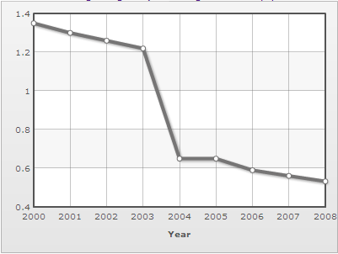

- The horizontal axis shows the years. Can you explain what the vertical axis shows?
- During which year did the growth rate decline most?

Vocabulary and Grammar

i. What is the verb related to the noun growth?
Try re-phrasing Hong Kong’s population growth rate 2000 – 2008 into everyday spoken English. You can begin “How [Adjective] the population of Hong Kong ….”

ii. Which of the following is closest in meaning to the verb decline?
- decrease
- increase
- change
- improve
iii. Here are some other verbs that can be used to describe trends. Check that you know what they all mean, how to use them in the past tense and how to change them into nouns.

VERB | PAST TENSE | NOUN
increase | increased | increase
decrease
change
shrink
expand
drop
fall
rise
climb
fluctuate

Note: These verbs are normally in the active voice when used to describe trends. For example:

The population increased rapidly throughout the 1960’s.
NOT
The population was increased rapidly throughout the 1960’s.

B. Here is a description of the above line graph.
Fig. 1 shows the Hong Kong population growth rate from 2000 to 2008. The growth rate declined considerably over this period, with a marked drop from 1.2% to 0.6% in 2003 to 2004.

Vocabulary and Grammar
i. Which verb is in the present tense? Why?
ii. Which verb is in the past tense? Why?

iii. Which of the following phrases are closest to the meaning of considerably as used in this text.

- by a huge amount
- by a small amount
- by quite a lot
- by hardly at all

iv. Here are some other adverbs that can describe upward or downward movement. Which of them say something about the speed of change, and which of them say something about the amount of change?

slightly, gradually, steadily, rapidly, sharply, hugely, steeply, suddenly, significantly

vi. Which of the following phrases are closest to the meaning of marked as used in this text.

a. shown clearly in the diagram
b. surprising and hard to explain
c. obvious and easily noticed
b. rapid and steep

vii. Look back at the list of adverbs given in iv above. How do you change them into adjectives? Which of the adjectives could be used before a noun like “drop”?

C. Now try writing your own descriptions of the results displayed in the following line graph.

Population Growth Rate in Ghana: 2000 – 2008

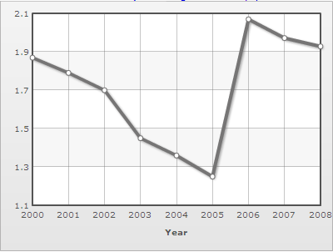

Task 2. Comparing results

A. Bar graphs are useful for comparing results. Here is a bar graph displaying some results from a study of waste disposal in a Hong Kong university.

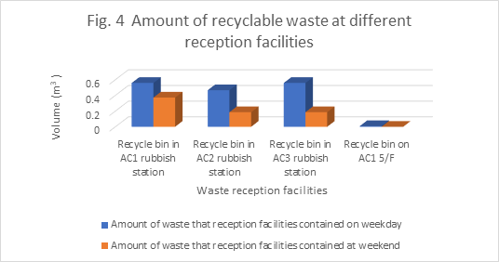
- What does the vertical axis show?

- What is the unit of measurement in the vertical axis?

- What does the horizontal axis show?

- Why are two different colours used?

- What do you think are the most interesting findings displayed in this graph?

Vocabulary and Grammar

i. Can you explain in everyday words what “recyclable waste” is? How many other words can you think of that are formed from a verb + able?

ii. What verb is related to the noun “reception”? Can you explain in everyday words what a “waste reception facility” is?
[Possible Answer: “A place where ….”
B. The following text is a description of the results displayed in the bar graph above.
Fig. 4 shows the volume of recyclable waste at different waste reception facilities on a weekday and at the weekend. The bin at the AC1 rubbish station contained the highest overall volume of recyclable waste, followed by the AC3 station bin and the AC2 station bin. In the bins at both the AC1 station and the AC3 station, the volume reached just over 0.6 m³ on the weekday. The recycling bin on AC1 5/F contained the lowest amount of recyclable waste, less than 0.1 m³. The graph also indicates that at all the stations the volume of recyclable waste disposed of on the weekday was higher than at the weekend.

Vocabulary and Grammar
- The description begins with the words “Fig.4 shows …” What other phrase in the text means almost the same as this?

- Can you explain why these two different prepositions are used?

at the ACI rubbish station in the bins
How about: on the weekday at the weekend”?

- Why do the adjectives “high” and “low” in the text sometimes end in -est and sometimes end in -er?

- Suppose that you found an equal volume of recyclable waste in the bins on the weekday and at the weekend, how would you rewrite the final sentence to express this? Begin: “The graph also indicates that at all the stations the volume of recyclable waste disposed of on the weekday was ………”

B. Now try writing a description of the results displayed in the following bar graph.

